Web Portal Design

Contents

The Dashboard 2

Navigation Pane 2

Default Folders 4

Activities 4

People 4

Places 5

Things 5

Management Pane 5

Managing Tasks 5

Managing Contacts 5

Managing Locations 5

Managing Items 5

Suggestions Pane 5

Appendix 6

Terminology 6

Data Model 6

Item 6

Field 6

FieldType 6

List 6

Folder 6

ItemType 6

# The Dashboard

The dashboard is the primary user interface for viewing and managing one’s tasks and schedule. The dashboard is partitioned into three functional panels; suggestions (left), folder management (center), and folder navigation (right).

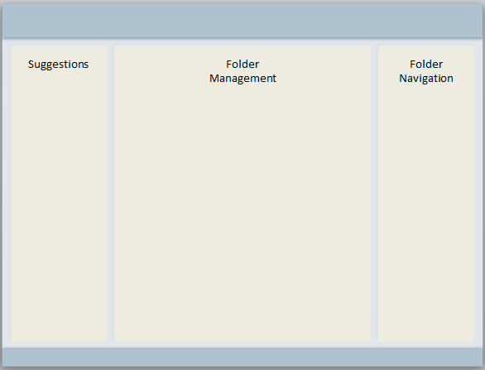

## Navigation Pane

The primary functions of the navigation pane are:

* allow one to quickly inspect the items contained within the folders
* allow one to easily reorder the folders and the items within a folder
* allow one to easily move items between lists within a folder
* allow one to add a new folder or a new sub-list to a folder
* allow one to drag or drop items onto the management pane
* allow one to select a folder to manage within the management pane

The navigation pane will display the set of top-level folders in a vertical list. Folders may contain an arbitrary hierarchy of lists and items. The navigation pane will allow one to expand and collapse these sub-lists for one given folder at a time. This allows one to quickly inspect the items within the folders, but does not allow one to add new or edit existing items.

Two folder selection gestures will be required, one for selecting a folder to navigate and another for selecting a folder for management. Selecting a folder for navigation will collapse the previously expanded folder. Each sub-list within a folder may also be expanded. The “expanded or collapsed” state for each folder will be remembered so the user can navigate between folders easily. If too many items are expanded within a given folder, a scrollbar will appear for navigating items within that folder.

Within the navigation pane, one may drag and drop the folders to change their display order. Within the currently selected folder, one may drag and drop items within a given list to change the display order of the items in that list. One may also drag and drop items between lists within the folder.

There will be a gesture for adding a new folder. One can set the name and default item type for the folder and it will be positioned at the bottom of the folder list. Within the currently selected folder, there will be a gesture for adding a new sub-list to that folder. One can set the name of the list, which will be of the same item type as the folder. (adding new lists within lists must be done thru the management pane).

One of the primary functions of the navigation pane is to allow one to drag and drop items or lists from one folder onto the lists or items within another folder in the management pane. This allows one to quickly set properties or attach related items or lists. This feature and examples will be described in more detail in the Management Pane section.

Selecting a folder for management will switch the focus of the management pane (center) to that folder. The management pane is used to fully manage and edit the lists and items within a folder.

## Default Folders

The data model for each user will be initialized with a set of default folders. Each default folder will consist of a different default ItemType and will provide a basic model for organizing the user’s information. The default folders are Activities (consisting of Task items), People (consisting of Contact items), Places (consisting of Location items), and Things (consisting of Basic items).

NOTE: Would prefer a name other than Things, what about using the name Items.

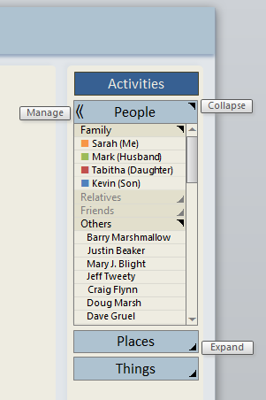 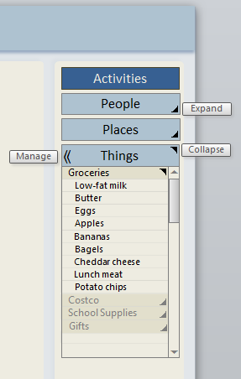

### Activities

This is the default folder for managing Task items. A Task item is one which defines some activity, event, or task (what), that needs to be done by a date & time (when), in some place (where), for someone (for), potentially by someone (by). This is the folder most often managed and viewed within the management pane (center). Because a task is associated with a date & time, it is often useful to view activities as a Calendar or Schedule.

### People

This is the default folder for managing Contact items. A Contact item is one which defines a person, business, or organization (who), that is located in some place (where).

### Places

This is the default folder for managing Location items. A Location item is one which defines a geographical location (where).

### Things

This is the default folder for managing Basic items. A Basic item is one which essentially consists of a name or noun (grocery items, favorite songs, gift ideas). There may be Basic item derivations which include fields specific to a type of item. For example, a Shopping item may include a field for defining the cost or price of the item.

## Management Pane

The primary functions of the management pane are:

* allow one to create and organize an arbitrary hierarchy of lists and items within a folder
* allow one to view, add, delete, and edit the items contained within a folder
* allow one to easily reorder the items within a folder
* allow one to easily move items between lists within a folder
* allow one to drag an item or list from navigation pane to attach to an item
* allow one to drag an item from navigation pane to set a field value for an item
* allow one drag an item or list from suggestion pane into a folder

The management pane is the primary view for managing a folder and the items and lists within. By default, all folders can be viewed and managed in “List” mode. This mode essentially allows one to view and manage the hierarchy of lists and items as a tree of lists.

### Managing Tasks

For folders that contain Task items, those items can be viewed and managed in “Schedule” mode. This mode allows one to view and manage the task items in terms of date & time (when). The “Schedule” mode will have numerous sub-modes for supporting an annual timeline, monthly calendar view, weekly calendar view, and daily agenda view.

### Managing Contacts

### Managing Locations

### Managing Basic Items

## Suggestions Pane

# Appendix

## Terminology

### Data Model

The data model refers to the hierarchy of items that are used to maintain the user data.

### Item

An item is the basic building block for the entire data hierarchy. An item consists of a set of fields and a list of other items.

### Field

A field is a property of an item consisting of a value.

### FieldType

A field type is both a name and a semantic type (which implies a system type).

### List

A list is just an item.

### Folder

A folder is a root-level item.

### ItemType

An item type refers to an item which contains of a set of specific field types.